**Assignment Day 12**

* **What is SQL?**

**SQL** stands **for Structured Query Language.** It is a programming language used to manage and interact with relational databases. It allows developers to perform various operations such as creating databases and tables, inserting data, updating records, retrieving information, and deleting unnecessary data. In web development, SQL plays a crucial role by enabling websites and applications to connect to a database and handle dynamic content. For example, when a user registers on a website, their information is stored in a database using SQL commands. Similarly, when products are displayed on an online store or when users log in to their accounts, SQL is used to retrieve and manage that data. Overall, SQL is essential for creating data-driven websites that require storing and manipulating large amounts of structured information efficiently.

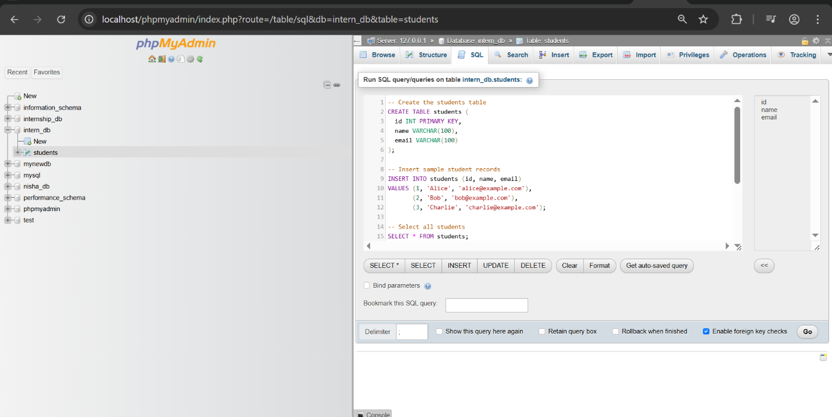

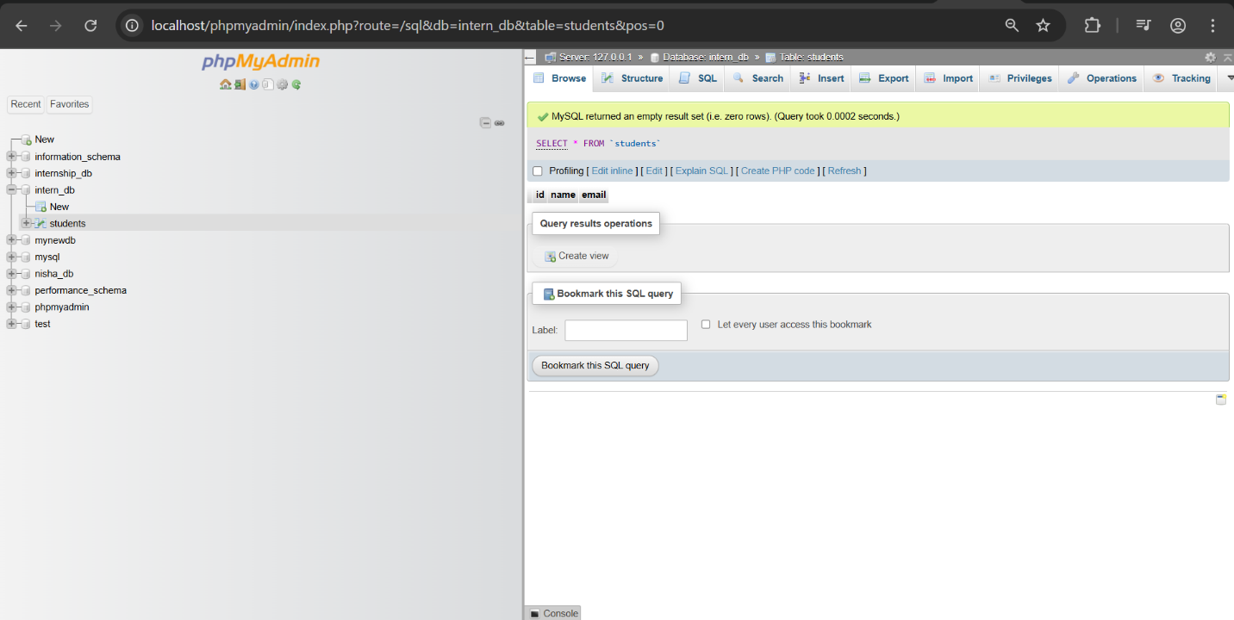

In todays task I learned the basics of SQL and its role in web development. I practiced using important SQL commands such as CREATE DATABASE, CREATE TABLE, INSERT INTO, SELECT, UPDATE, and DELETE. I created a database named internship_db, added a table called students, inserted sample records, and performed operations to retrieve, update, and delete data using both the MySQL command line and phpMyAdmin.